**EXP NO 10** Create a simple cloud software application for Payroll Processing System using any Cloud Service Provider to demonstrate SaaS include the necessary fields such as Name of the employee, experience in present org, over all experience, basic pay, HRA, DA, TA, net pay, gross pay etc.

**AIM:**

TO create a simple cloud software application for online student Counselling system using any cloud service provider to demonstrate saas.

**PROCEDURE:**

**STEP1:** GOTO ZOHO.COM STEP

**STEP2:** LOGIN TO THE ZOHO.COM STEP

**STEP 3**: SELECT ONE APPLICATION STEP

**STEP 4:** ENTER APPLICATION NAME STEP

**STEP 5:** CREATED NEW APPLICATION STEP

**STEP 6:** SELECT ONE FORM STEP

**STEP 7:** THE SOFTWARE HASE BEEN CREATE

**PROCEDURE**

**STEP 1** GO TO ZOHO.COM

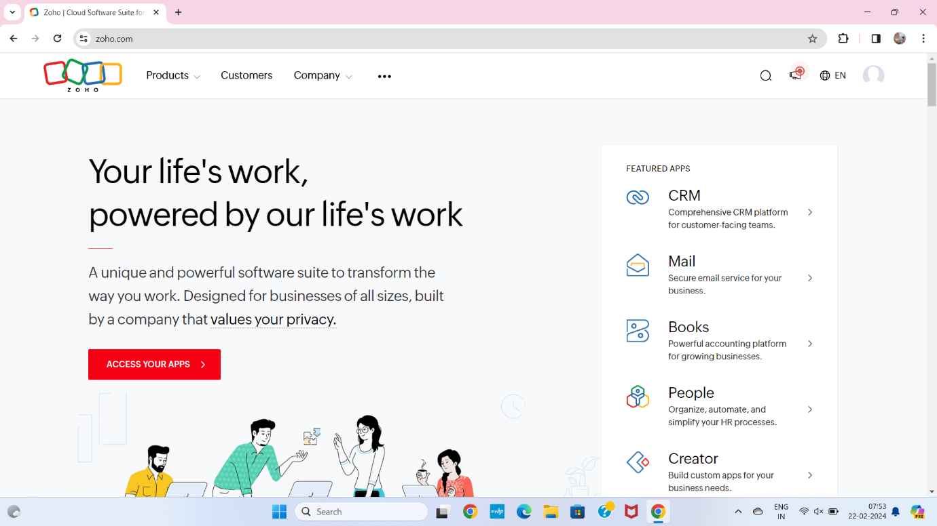

**STEP2** LOGIN TO THE ZOHO.COM

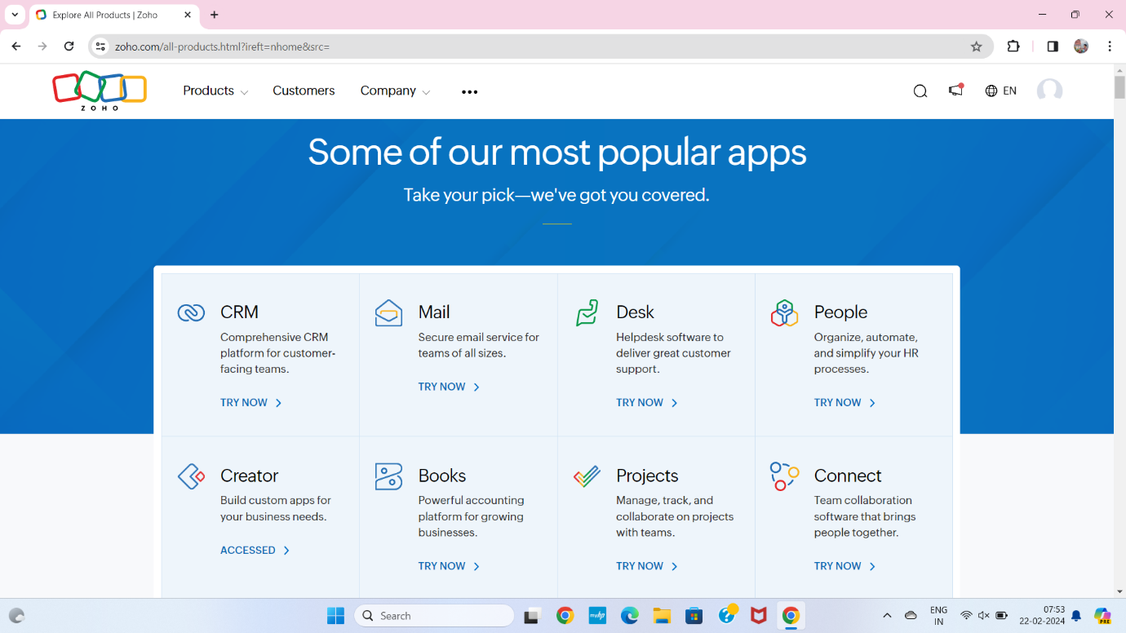

**STEP 3** SELECT A CREATE FROM SCRATCH

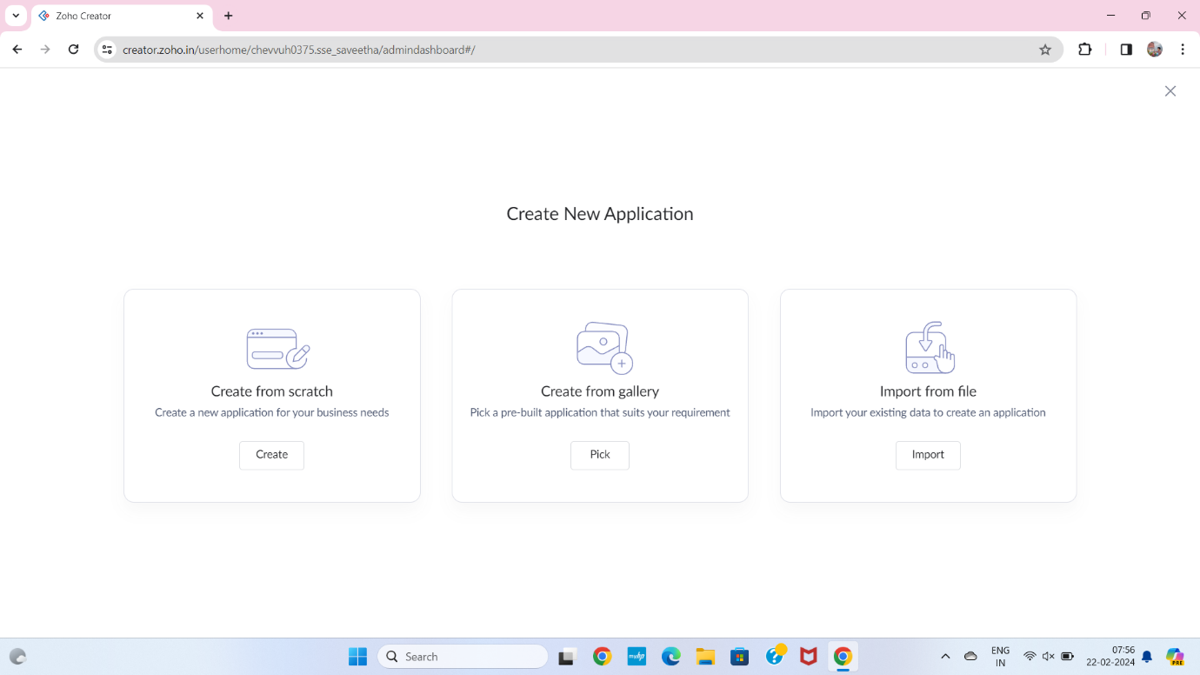

**STEP 4** SELECT APPLICATION NAME AS PAY ROLL PROCESSING SYSTEM

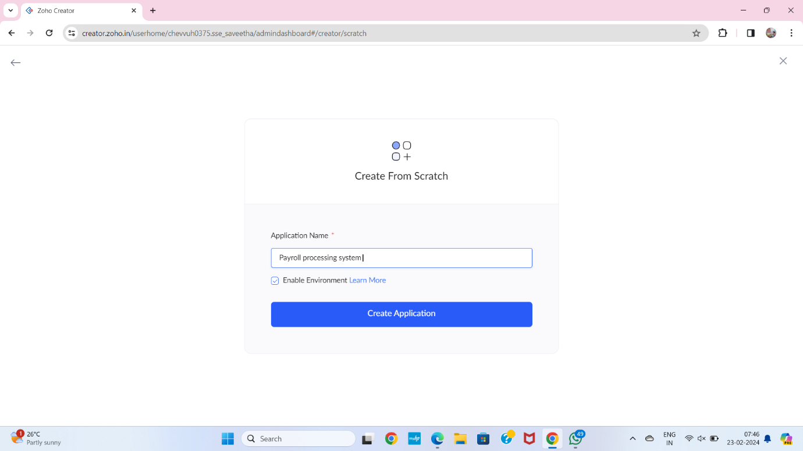

**STEP 5** CREATE A NEW FORM

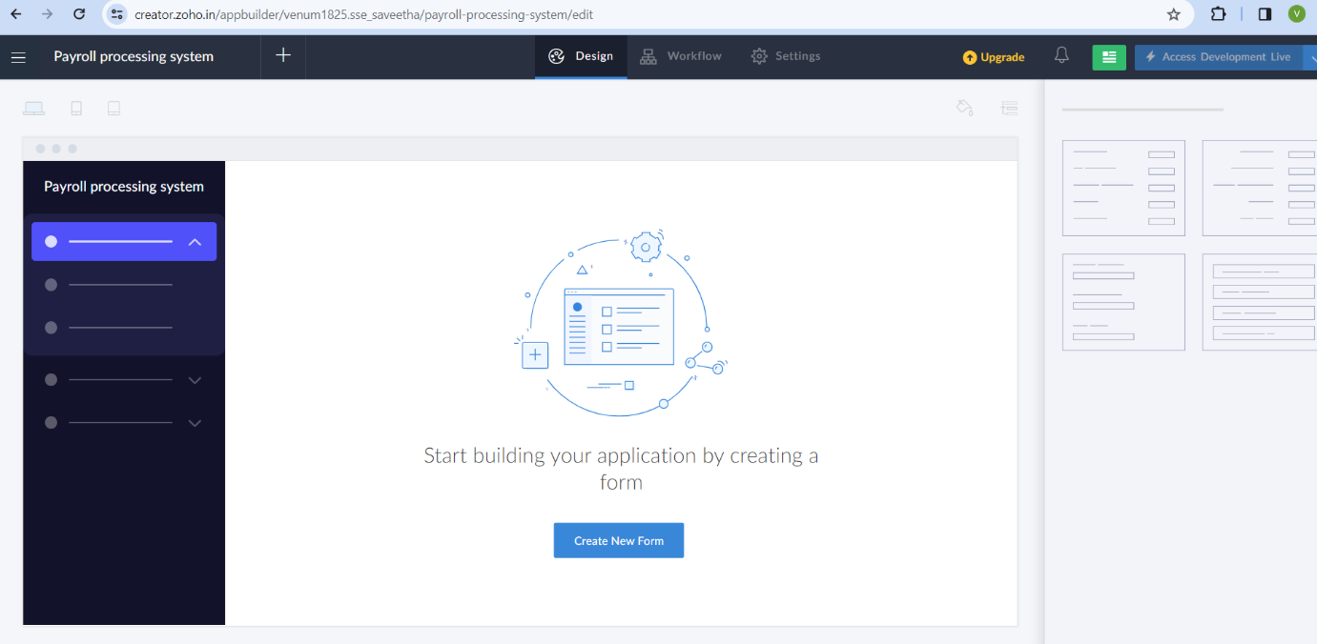

**STEP 6** SELECT BASIC FIELD FROM GIVEN BELOW AND DEVELOP APPLICATION

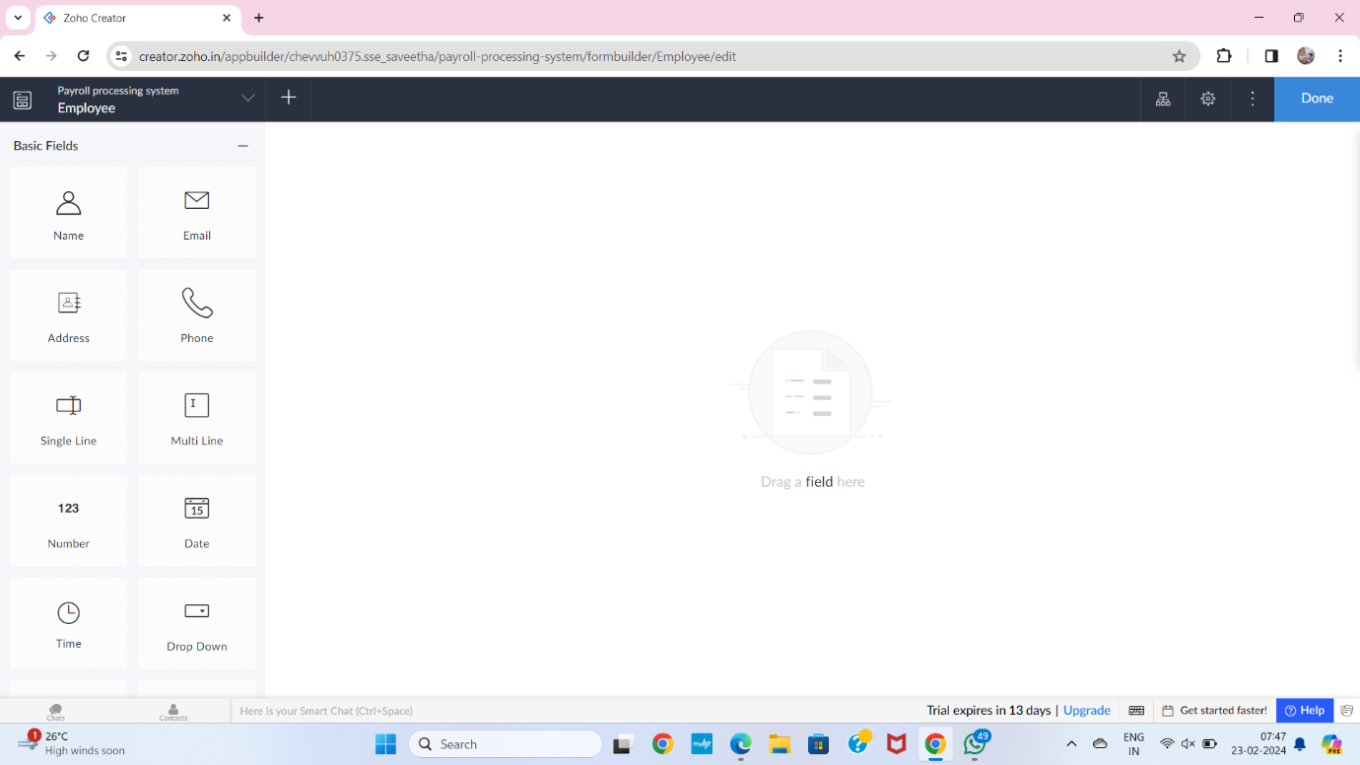

**STEP 7** THE SOFTWARE HASE BEEN CREATED EMPLOYEE

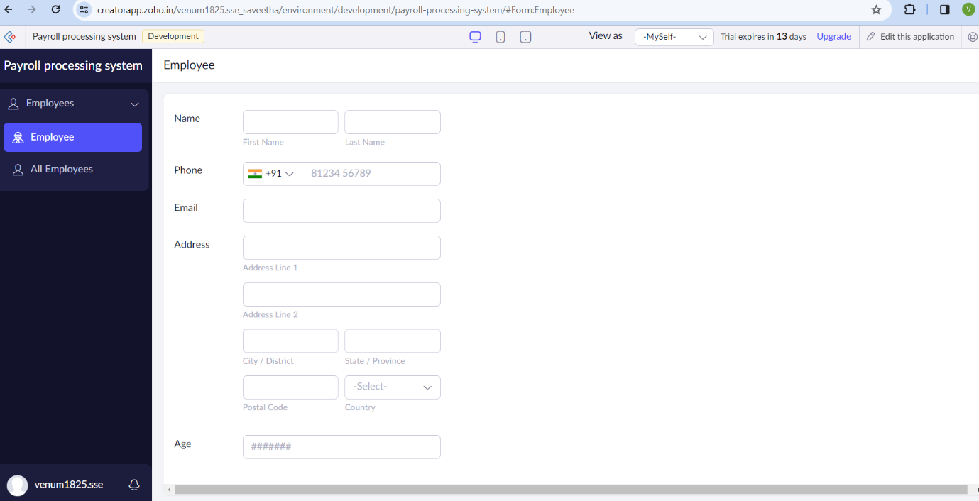

**STEP 8** THE SOFTWARE HASE BEEN CREATED SALARY

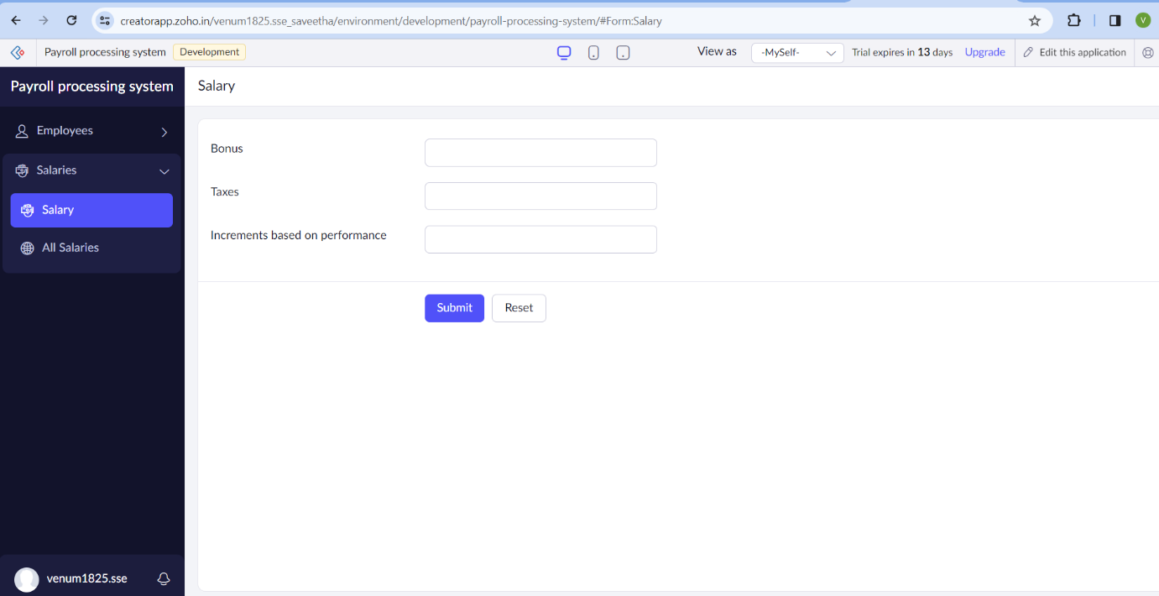

**STEP 9** THE SOFTWARE HASE BEEN CREATED EXPERIENCE OF WORK

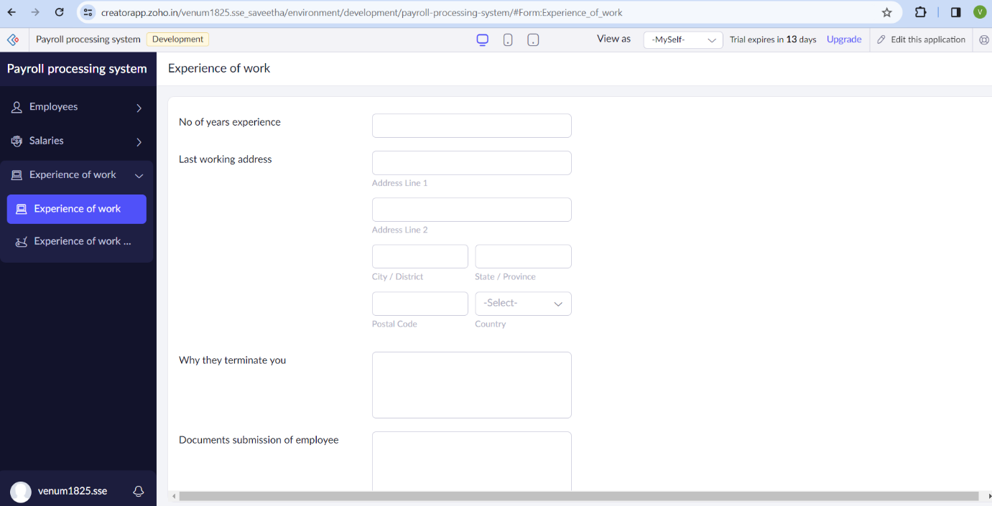

**STEP 10** THE SOFTWARE HASE BEEN CREATED PAY ROLL IN COMPANY

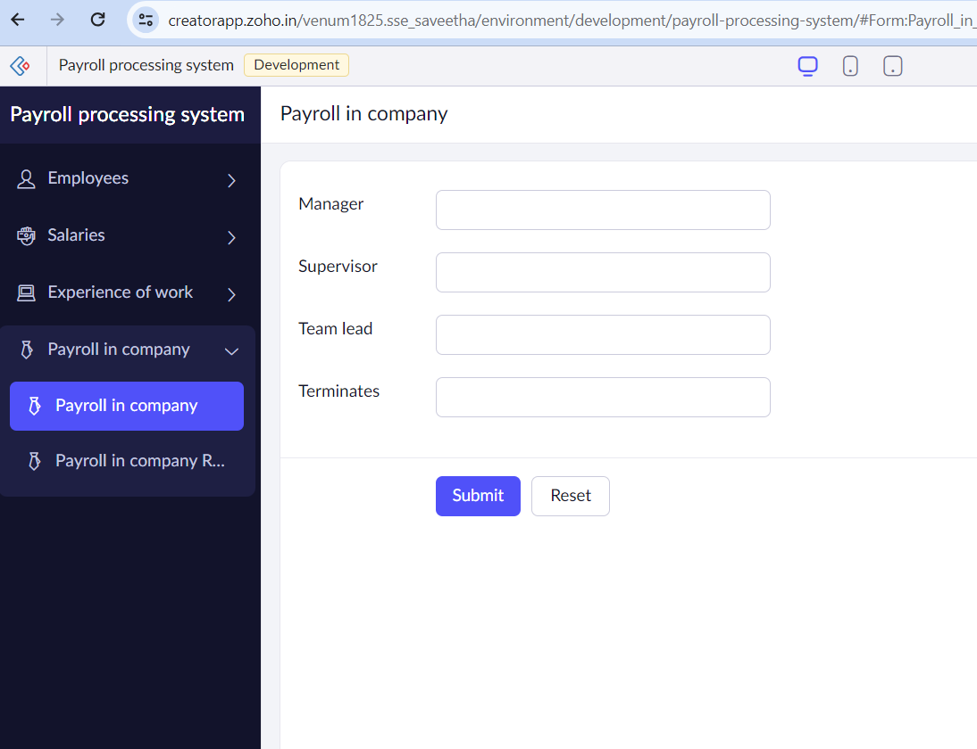

**STEP 11** THE SOFTWARE HASE BEEN CREATED

